Mitosis and the Cell Cycle

– How the Trillions of Cells in a Human Body Developed from a Single Cell

Cells, Chromosomes and Genes

Every person started as a single cell – a fertilized egg.

1. How do you think a single cell developed into the trillions of cells in your body?

Before you learn how new cells are made, we should review what chromosomes and genes are.
- Each chromosome contains a long molecule of DNA.  - Each DNA molecule contains many genes.  - A gene is a segment of a DNA molecule that gives the instructions for making a protein. Many of these proteins are needed for normal cell structure and function.  2. Explain why each cell needs to have a complete set of chromosomes. Include genes and proteins in your answer. | 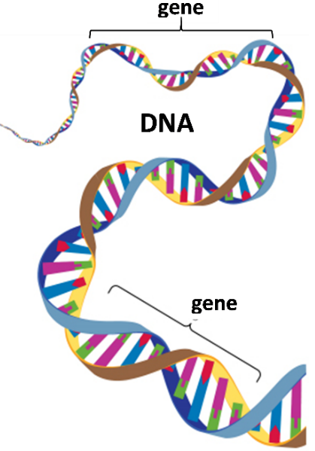

How does the number of cells increase? This figure shows the answer – one cell divides into two daughter cells.

Each daughter cell has half as much cytoplasm and half as much DNA as the cell that divided. However, each daughter cell receives a complete set of chromosomes.

3. Suppose that, after the cell division shown in the figure, each daughter cell is preparing for another cell division. In the second column of the table, describe two things that each daughter cell would need to do to be ready for another cell division.

How a cell prepares for cell division
Hint 1: Remember that each new daughter cell will need a complete set of chromosomes.
Hint 2: What else would the cell need to do to be big enough to divide?
The Cell Cycle – How One Cell Becomes Two Cells
This figure shows the cell cycle, which begins with a single cell and produces two daughter cells.

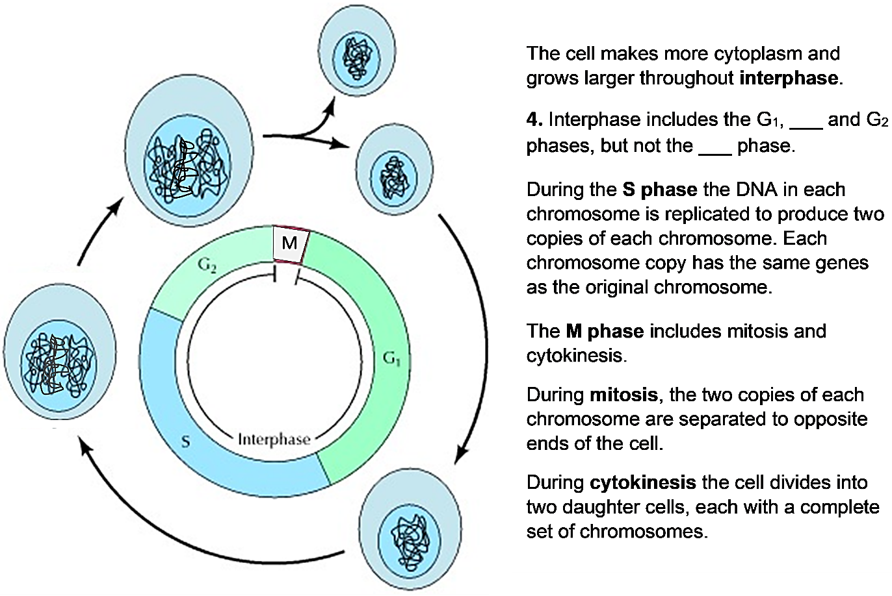
5a. The cell cycle produces two daughter cells, and each daughter cell can begin a new cell cycle. Circle the cell in the figure that represents both a daughter cell that has been produced by the cell cycle and a cell that is beginning a cell cycle.

5b. Explain why the cell is smallest at this time in the cell cycle.

6a. Use 2x to label the arrow(s) when the amount of DNA doubles.

6b. Use ½ to label the arrow(s) when the amount of DNA in each cell is halved.

7. Complete this table to explain why specific phases of the cell cycle are required for successful cell division.

What would go wrong if the cell cycle occurred without the S phase?
What would go wrong if the cell cycle occurred without cytokinesis?

8. How do you think that a cell accomplishes mitosis? How are the two copies of each chromosome separated so that each daughter cell gets a complete set of chromosomes?

Mitosis – How Each Daughter Cell Gets a Complete Set of Chromosomes

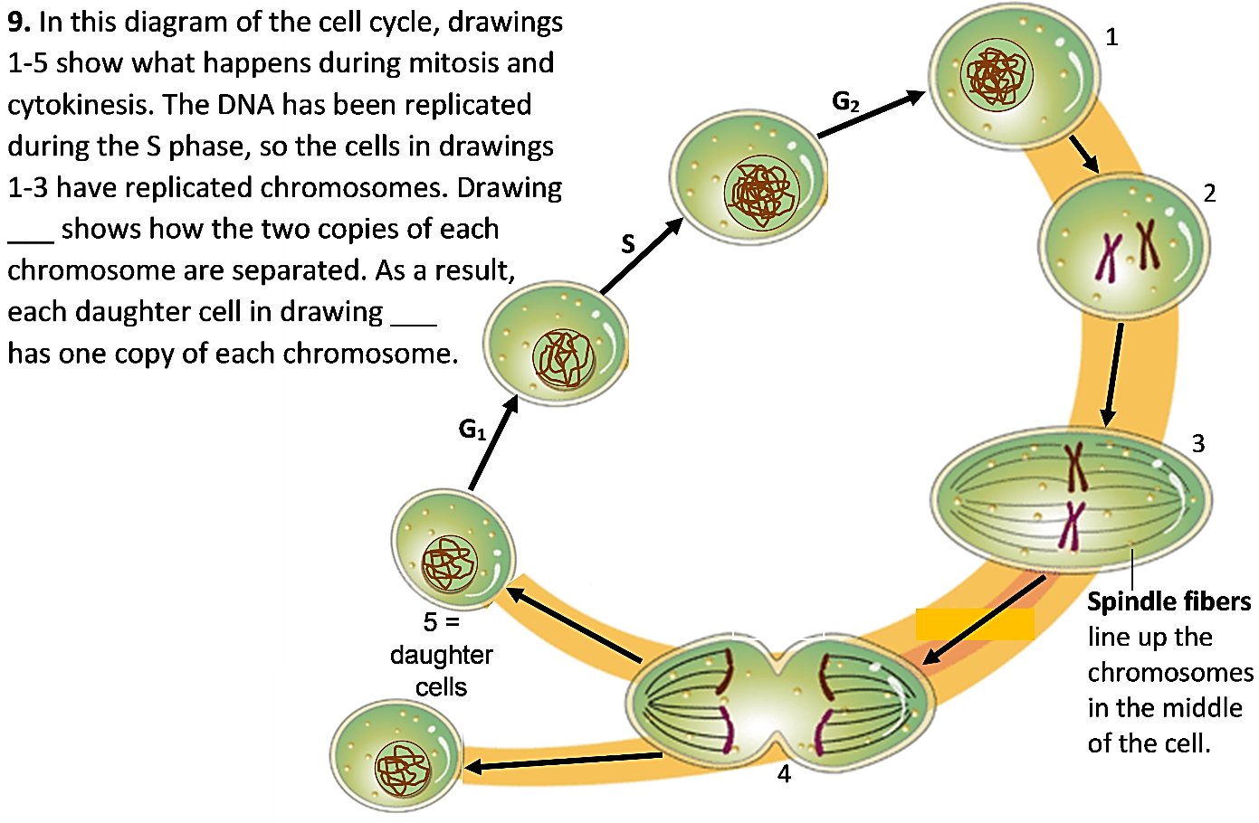

Notice that the chromosomes have a different shape in drawings 2-4, compared to other times
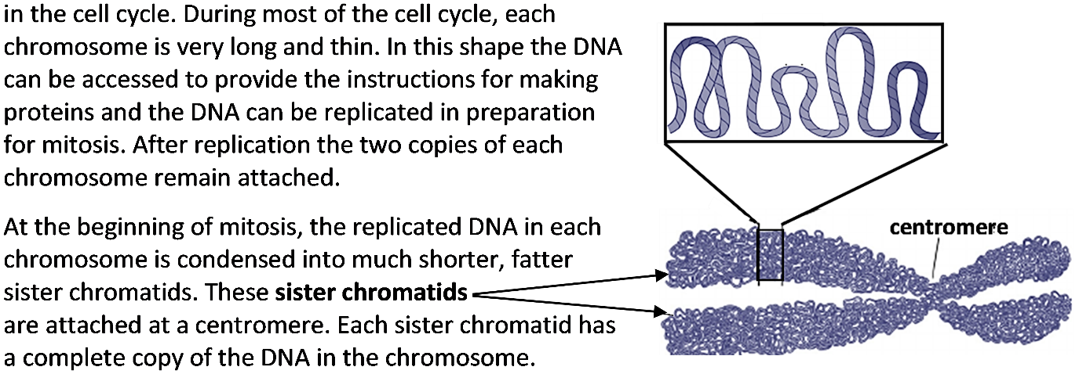

10a. Do the two sister chromatids have the same genes? yes ___ no ___
10b. How do you know?

11a. Put the letter for each of these descriptions next to the appropriate drawing in the top figure.
- In the daughter cells, DNA has unwound into long thin threads so genes in the DNA can be accessed to provide the instructions for making proteins.
- Near the beginning of mitosis, the replicated DNA has been condensed into sister chromatids.
- Spindle fibers have separated the sister chromatids into independent chromosomes. Cytokinesis begins.
11b. In drawings 2 and 3 there are two chromosomes, each with sister chromatids. In drawing 4 there are four chromosomes with no sister chromatids. Explain what happened.

12. The figure below shows six stages of cell division for a cell that has two pairs of chromosomes, but these stages are not shown in the correct sequence.
- Draw arrows to show the correct sequence for these stages of cell division.
- Use an * to mark the arrow which shows when sister chromatids are separated to become individual chromosomes.
- Label the drawing that shows the beginning of cytokinesis.

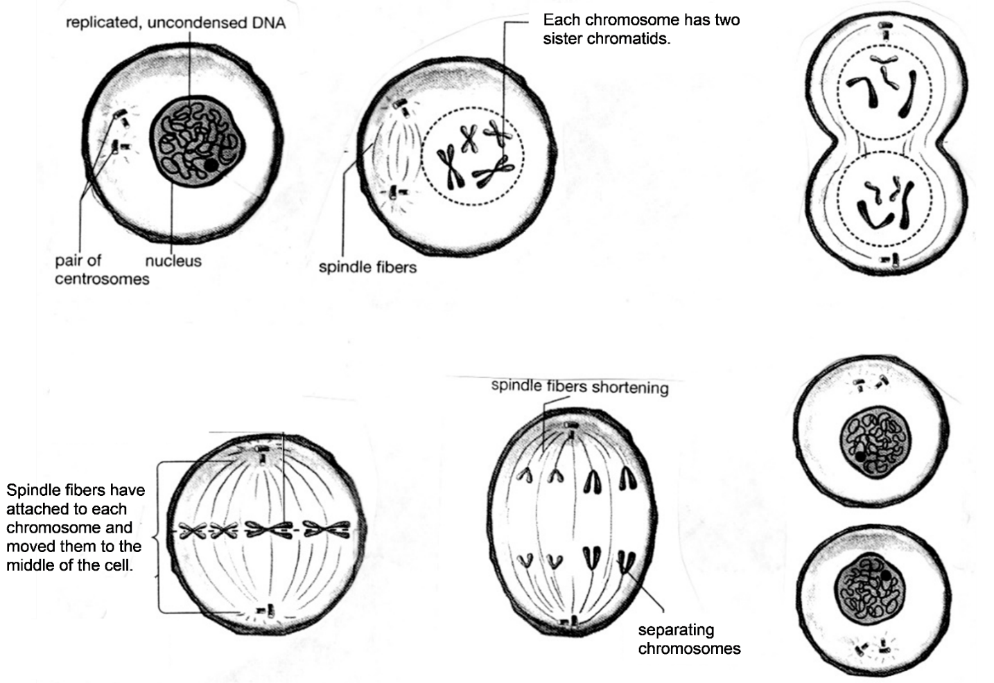

13. The chromosomes are very long and thin chromosomes during interphase (the G₁, S, and G₂ phases of the cell cycle). Suppose that the chromosomes did not condense into shorter fatter sister chromatids at the beginning of mitosis. What problems could occur if the chromosomes had a very long thin shape during mitosis?

14. Explain how DNA replication, mitosis and cytokinesis ensure that each daughter cell has the same genes as the original cell.

How Repeated Cell Division Can Make Trillions of Cells

Each of us began as a single cell which divided into two daughter cells. How can multiple repetitions of one cell dividing into two cells produce the trillions of cells in a human body? To understand, answer the questions below.

15a. Complete this table to show the number of cells an embryo would have if every cell divided each day, so the number of cells doubled each day.

Day | 1 | 2 | 3 | 4 | 5 | 6 | 7 | 8 | 9 | 10 | 11
# Cells | 1 | 2 | 4

15b. On day 2 there was only 1 more cell than on the previous day.
On day 6 there were ______ more cells than on the previous day.
On day 11 there were _______ more cells than on the previous day.

15c. Explain why more cells were added on day 11 than on any previous day.

16a. An embryo begins as a single cell. If each cell divides each day, then the number of cells will double each day. 10 days after day 1, the number of cells will be multiplied by 2¹⁰, which is approximately 1000. If the number of cells is multiplied by 1000 = 10³ every 10 days, approximately how many cells will there be after 20 days of cell division?

16b. Approximately how many cells will there be after 40 days of cell division?

As an embryo grows, the number of cells available to divide increases, so cell division can add more and more cells each day. This explains how cell division can produce more than a trillion cells in a newborn baby, starting from a single cell just nine months earlier!

17. To summarize what you have learned, explain how a single cell developed into the trillions of genetically identical cells in your body. A complete answer will include the following terms.
DNA replication, mitosis, sister chromatids, spindle fibers, chromosomes, cytokinesis, daughter cells, genes.

18. Even in a fully grown adult, some cells continue to divide. Why is cell division useful in an adult who is no longer growing? (Hint: Think about what happens when you have an injury that scrapes off some of your skin.)

Cell Differentiation

Repeated cell division produced the trillions of genetically identical cells in your body. Obviously, your body is not just one big blob of trillions of the same type of cell. During development, cell differentiation converted your cells into the many different types of specialized cells in your body.
19. Give a brief description of the function of each type of cell shown in this figure. | 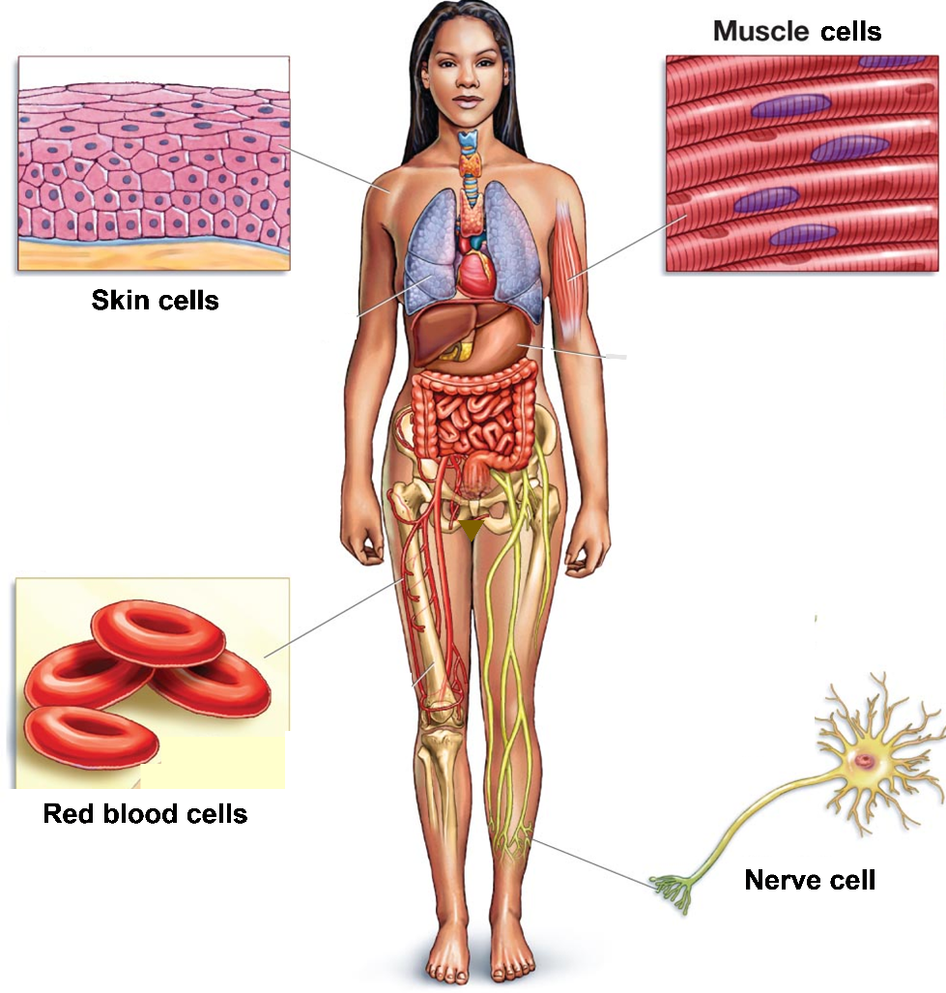
Different types of cells have different types of proteins. For example, red blood cells have lots of hemoglobin to carry oxygen, while skin cells have lots of keratin which helps to make the skin strong and waterproof.

Since your cells are produced by mitosis, each cell begins with a complete set of genes. However, in each type of cell, some genes are turned on for protein production, and other genes are turned off. Different genes are turned on in different types of cells.

20a. Which gene or genes are in the DNA of each type of cell shown? Write the letters inside each cell.  H = gene that gives the instructions to make hemoglobin  K = gene that gives the instructions to make keratin | Cell that is differentiating to become a:
 | red blood cell | skin cell

20b. In each type of cell, put an * next to the letter of the gene that you would expect to be turned on for protein production.

Turning on specific genes for protein production is part of the complex processes of cell differentiation and development.

By Drs. Ingrid Waldron, Jennifer Doherty, Scott Poethig and Lori Spindler, Dept Biology, Univ Pennsylvania, © 2022. This Student Handout and Teacher Notes with instructional suggestions and background information are available at https://serendipstudio.org/exchange/bioactivities/MitosisRR.

